

Name: Lim Ying jia

Login ID: limyingjia@oasisportal.com

Course title: Accounting Fundamentals

Subject Code: BHM03

Submitted date: 07-08-2017

**Table of Contents**

|  |  |  |
| --- | --- | --- |
| No | Details | Page |
| 1 | Executive Summary | 3 |
| 2 | Introduction | 4 |
| 3 | Assignment Question |  |
|  | Part 1 | 5-7 |
|  | Part 2 | 8 |
|  | Part 3 | 9-15 |
|  | Part 4 | 16-20 |
| 4 | Conclusion | 21 |
| 5 | References | 22-23 |
| 6 | Appendix | 24 |

**Executive Summary**

In this module, I learned about accounting fundamentals. It is about the methods for recording transactions,keeping financial records, performing internal audits,reporting and analyzing financial information to the management, and advising on taxation matters. For the firstly , I learned the role of accounting. So I will defind what my understanding in the role of accounting. Secondly, I studied what is the difference between accounts payable and receivable. Furthermore , I will explain about why does a company’s profit appear as a credit on its balance sheet. So I also will defind accounting equation and trading and profit and loss account. Finally , I can explain what is the meaning of reconciliation account.

**Introduction**

In this assignment, I learned and understand about the essentials of marketing and customer relationship. I have studied about the process of communicating financial information about a business entity to users such as shareholders and managers , inputs in to accounting include journal entries and the bookkeeping process , and the general ledger. For the very first part , I learned about the profession of a accounting consisting of individuals having the formal education to carry out these tasks.Second part , One part of accounting focuses on presenting the information in the form of general-purpose [financial statements](https://www.accountingcoach.com/blog/what-is-a-financial-statement" \o "What is a financial statement?)  to people outside of the company. I have also learned about the difference between Debtor and Creditor . I covered the topic , I understanding the ethics of Accounting . Furthermore , I can describe about a role of accounting and how I apply my studies in account management. I do explain in detail on accounting is importance in real life especially used in company. Finally , another part of accounting involves compliance with government regulations pertaining to income tax reporting.

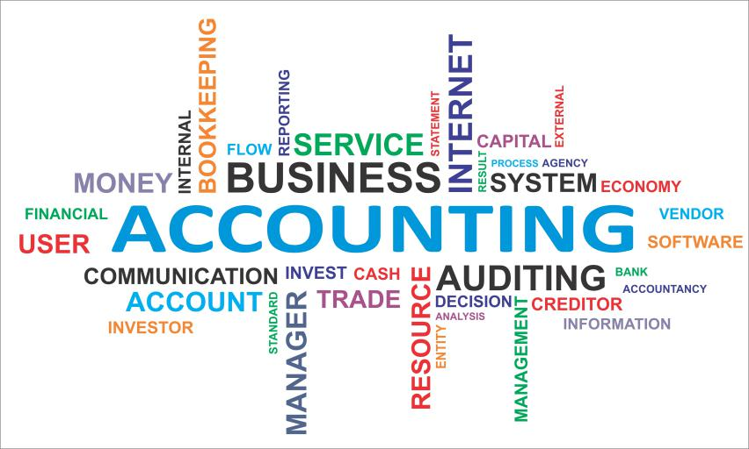

Figure 1 ( Idea of accounting, 2016 )

**Assignment Questions**

**Question 1**

What is accounting ? Defind accounting concept ( meaning of accounting )

Answer :

-Meaning of accounting

methods for recording transactions,keeping financial records,  
performing internal audits,reporting and analyzing financial information to the management, and advising on taxation matters. It is a systematic process of identifying, recording, measuring, classifying, verifying, summarizing, interpreting and communicating financial information. It reveals profit or loss for a given period, and the value and nature of a firm's assets, liabilities and owners' equity . Besides that , Accounting provides information on the resources available to a firm, the means employed to finance those resources, and the results achieved through their use.

-History of accounting

The history of accounting is a system of recording and summarizing business and financial transactions. For as long as civilizations have been engaging in trade or an organized system of government, methods of record keeping, accounting and accounting tools have been in use.

Some of the earliest known writing discovered by archaeologists are accounts of ancient tax records on clay tablets from Egypt and Mesopotamia dating back as early as 2,000 to 3,300 B.C.

It is hypothesized that the primary reason for the development of writing systems came out of a need to record trade and business transactions.

### **ACCOUNTING REVOLUTION**

When medieval Europe moved towards a monetary economy in the 13th century, merchants depended on bookkeeping to oversee multiple simultaneous transactions financed by bank loans.

In 1458, Benedetto Cotrugli invented the double-entry accounting system, which revolutionized accounting. It is defined as any bookkeeping system that involves a debit and/or credit entry for transactions. Italian mathematician and Franciscan monk Luca Bartolomes Pacioli invented a system of record keeping such as using a memorandum, journal and ledger. Pacioli wrote many books on accounting.

### **FATHER OF ACCOUNTING**

Born in 1445 in Tuscany, Pacioli is known today as the father of accounting and bookkeeping. He wrote Summa de Arithmetica, Geometria, Proportioni et Proportionalita, which means "The Collected Knowledge of Arithmetic, Geometry, Proportion and Proportionality " in 1494, which included a 27-page treatise on bookkeeping.

His book was one of the first books published using the historical [Gutenberg press](https://www.thoughtco.com/johannes-gutenberg-and-the-printing-press-1991865) and the included treatise was the first known published work on the topic of double-entry bookkeeping.

One chapter of his book, Particularis de Computis et Scripturis, which translates to mean "details of calculation and recording" on the topic of record keeping and double-entry accounting, became the reference text and teaching tool on those subjects for the next several hundred years.

The chapter educated readers about the use of journals and ledgers as well as keeping account of assets, receivables, inventories, liabilities, capital, income, expenses, keeping a balance sheet and making an income statement.

After Luca Pacioli wrote his book, he was invited to teach [mathematics](https://www.thoughtco.com/history-of-mathematics-1992130) at the Court of Duke Lodovico Maria Sforzo in Milan. Artist and inventor [Leonardo da Vinci](https://www.thoughtco.com/inventions-of-leonardo-davinci-4122923) was one of Pacioli's students. Pacioli and da Vinci became close friends. Da Vinci illustrated Pacioli's manuscript De Divina Proportione, meaning "Of Divine Proportion" and Pacioli taught da Vinci the mathematics of perspective and proportionality.

### **CHARTERED ACCOUNTANTS**

The first professional organizations for accountants were established in Scotland in 1854, starting with the Edinburgh Society of Accountants and the Glasgow Institute of Accountants and Actuaries. The organizations were each granted a royal charter. Members of such organizations could call themselves chartered accountants.

As companies proliferated, the demand for reliable accountancy shot up, and the profession rapidly became an integral part of the business and financial system. There are now organizations for chartered accountants all over the world.

In the U.S., the American Institute of Certified Public Accountants was established in 1887.

-Double entry

Double entry means that every transaction will involve at least two [accounts](https://www.accountingcoach.com/blog/what-is-an-account" \o "What is an account?). For example, if your company borrows money from the bank, the company's asset Cash is increased *and* the company's [liability](https://www.accountingcoach.com/blog/what-is-a-liability" \o "What is a liability?) Notes Payable is increased. If your company pays the six-month insurance premium, your company's asset Cash is decreased *and* its asset [Prepaid Insurance](https://www.accountingcoach.com/blog/what-is-prepaid-insurance" \o "What is prepaid insurance?) is increased. If an employee works for hourly wages, the company's account Wages Expense is increased *and* its [liability account](https://www.accountingcoach.com/blog/what-is-a-liability-account" \o "What is a liability account?) Wages Payable is increased. When the employee is paid, the account Wages Payable is decreased *and* Cash is decreased.  
  
Double entry also requires that one account be [debited](https://www.accountingcoach.com/blog/meaning-of-debit" \o "What is the meaning of debit?) and the other account be [credited](https://www.accountingcoach.com/blog/what-is-a-credit" \o "What is a credit?). Accounting software might record the effect on one account automatically and only require information on the other account. For example, if you are preparing a check, the software will automatically reduce the Cash account. Therefore, the accounting software needs only to prompt you for information on the other account involved in the payment being processed.

-Role of accounting

The role of accounting in business is to help internal and external stakeholders make better business decisions by providing them with financial information.Next,accounting communicates informations that owenrs,manager, and investora need to evaluate a company financial performance . They also play a main role on work in one of two major fields management accounting which helps you keep your business running , or financial accounting which tells you how well you running it . The purpose of management accouting is to supply relevant ,accurate ,timely information to managers in a format that will aid them in making decisions . The purpose of financial accounting is to provide information that helps with the assesment of a firm financial history and current performance . Lastly , financial accounting includes income statements , balance sheet , and statements of cash flow . Above up was a role of an accounting

**Question 2**

Explain the difference between account receivable and account payable

|  |  |
| --- | --- |
| Accounts Receivable | Accounts Payable |
| [Accounts receivable](https://www.accountingcoach.com/blog/what-is-accounts-receivable" \o "What is accounts receivable?) are amounts a company has a right to collect because it sold goods or services on credit to a customer. Accounts payable are [liabilities](https://www.accountingcoach.com/blog/what-is-a-liability" \o "What is a liability?). Accounts receivable are assets. | [Accounts payable](https://www.accountingcoach.com/blog/what-is-an-account-payable" \o "What is an account payable?) are amounts a company owes because it purchased goods or services on [credit](https://www.accountingcoach.com/blog/what-is-a-credit" \o "What is a credit?) from a supplier or [vendor](https://www.accountingcoach.com/blog/what-is-a-vendor" \o "What is a vendor?). |
| it is a type of record that companies use to maintain in order to keep track on money they owe to their clients whom they have been served in terms of invoices | It’s a process of maintaining a record known as AP sub- ledger (balance sheet of company) to keep track on money that is owed by a business to its suppliers. |
| The total amount payable in the end of the month with additional charges for debtors | The variation of amount owed at the end of the month for debtors |
| Accounts Receivables is the amount that a company use to claim from their clients for services they have provided or goods been supplied on order. | The amount is firstly recorded at the time when the order is been vouchered for the payment. |
| The total amount of money that the company claims for goods or services, including other charges | The amount of money payable for services and goods the company ordered, including other costs. |
| The sales a business has made through invoice | The purchase a business has made |

**Question 3**

**Why does a company profit appear as a credit on its balance sheet .**

-Balance Sheet is the financial statement of a company which includes assets, liabilities, equity capital, total debt, etc. at a point in time. Balance sheet includes assets on one side, and liabilities on the other. For the balance sheet to reflect the true picture, both heads (liabilities & assets) should tally (Assets = Liabilities + Equity). The accounting equation and the double entry system provide an explanation why a company's profit appears as a credit on its balance sheet.Asset accounts usually have debit balances while liabilities and owner's or stockholders' equity usually have credit balances. When a company provides services for cash, its asset Cash is increased by a debit and its owner's equity is increased by a credit. The credit is initially recorded in a revenue account, but revenue accounts are temporary accounts that cause owner's equity to increase.If the owner withdraws some cash for personal use, the asset Cash will decrease through a credit and the owner's equity will decrease through the debit part of the accounting entry. The debit might initially be recorded in the sole proprietor's Drawing account but this account is also a temporary account that will cause the owner's equity to decrease.Generally speaking, the credit balance reported in the owner's or stockholders' equity section of the balance sheet reflects the owners' investments in the company plus the profits earned minus the amounts distributed to the owners since the time that the company began.

Equity and Capital $

Opening Capital 43,500

Net 8,500

# 52,000

Drawings ( 7,600 )

27,400

Current Liability

Creditor 2300

Non-Current Liability

Bank Loan 10,000

56,700

Accounting Equation

Answer :The equation is a simplified breakdown of the values entered in the balance sheet. It illustrates the relationship between a company's [assets](https://debitoor.com/dictionary/assets), [liabilities](https://debitoor.com/dictionary/liabilities) (amounts owed to others), and shareholder or owner [equity](https://debitoor.com/dictionary/stockholders-equity) (the value of an asset minus the liabilities associated with that particular asset).

## **Balance in accounting**

The accounting equation shows the balance of a company’s resources (those displayed on the [balance sheet](https://debitoor.com/dictionary/balance-sheet) as assets). The company’s [assets](https://debitoor.com/dictionary/assets) are shown on the left side of the equation, and the [liabilities](https://debitoor.com/dictionary/liabilities) and [equity](https://debitoor.com/dictionary/stockholders-equity) (the total claims to those assets) are shown on the right side. The equation illustrates that all of a company’s resources (assets) are provided by their [creditors](https://debitoor.com/dictionary/creditor) or their owners ( through liabilities and equity).

The accounting equation also shows that every economic event that affects the balance sheet will have a dual effect: a company’s resources will always have equal claims.

## **The equation and what it means**

The equation is typically written as:

Assets = Liabilities + Owner Equity

It can also be structured as:

Liabilities = Assets - Owner Equity

Owner Equity = Assets - Liabilities

The accounting equation is a simple way to view the relationship of financial activities across a business. The balance sheet essentially takes care of filling in each of the values in the equation, so the equation is not meant for actual use but is instead a simplified representation of how the financial side of a business functions.

## **The accounting equation in action**

An example of how the three values relate: If a business wishes to purchase a new asset, such as computer equipment that costs £300, the purchase can be made using cash (an asset), with owner equity (earnings or funds) or with a liability (such as borrowed money). If a liability is used for the purchase, the £300 can then be paid off using assets or with the use of a new liability, such as a bank loan

**Trading profit and loss account**

Define

-One of the main aims of operating a business is to make profit. Profit is calculated in a Trading and Profit and Loss Account. This is divided in a Trading Account which calculates the Gross Profit for the period, and a Profit and Loss Account which calculates Net profit for the period.

*The Trading Account* ─ calculates the profit made strictly from trading activities. Trading involves buying and selling. In the trading account the cost of goods sold is subtracted from Net Sales for the period to calculate Gross Profit.

*Cost of Goods Sold* ─ the value of the goods sold at cost.

*Net Sales* ─ the actual sales made after all adjustments have been made for goods returned.

*Gross Profit* ─ this is the excess of Net Sales over Cost of Goods Sold.

*Gross Loss* ─ this is the excess of Cost of goods sold over Net Sales.

At the end of a financial period, all expense and revenue accounts are closed to a summarizing account usually called a Profit and Loss Account. This is the financial statement that summarizes revenues and expenses for a specific period of time, usually a month or a year.

*The Profit and Loss Account* reflects a Period of Time – Month, Quarter, Year. It shows financial the activity of a business during that period and indicates any profit or loss earned.

*Revenue*  ─ is the value of goods and services which have been delivered to customers.

*Expenses*  ─ costs incurred in earning these revenues.

*Net Profit* ─ is the excess of Revenue over Expenses, on the Profit and Loss Account.

*Net Loss* ─ is the excess of Expenses over Revenue, on the Income Statement

Theory

- The profit and loss statement, commonly referred to as the income statement, is one of three financial statements every public company issues quarterly and annually, along with the [balance sheet](http://www.investopedia.com/terms/b/balancesheet.asp) and the [cash flow statement](http://www.investopedia.com/terms/c/cashflowstatement.asp). The income statement, like the cash flow statement, shows changes in accounts over a set period of time. The balance sheet, on the other hand, is a snapshot, showing what is owned and owed at a single moment. It is important to compare the income statement with the cash flow statement, since under the [accrual method of accounting](http://www.investopedia.com/terms/a/accrualaccounting.asp), revenues and expenses can be logged before cash actually changes hands.

The income statement follows a general form as seen in the example below. It begins with an entry for [revenue](http://www.investopedia.com/terms/r/revenue.asp), known as the "top line," and subtracts the costs of doing business, including [cost of goods sold](http://www.investopedia.com/terms/c/cogs.asp), [operating expenses](http://www.investopedia.com/terms/o/operating_expense.asp), [tax expense](http://www.investopedia.com/terms/t/tax-expense.asp) and [interest expense](http://www.investopedia.com/terms/i/interestexpense.asp). The difference, known as [the bottom line](http://www.investopedia.com/terms/b/bottomline.asp), is [net income](http://www.investopedia.com/terms/n/netincome.asp), also referred to as [profit](http://www.investopedia.com/terms/p/profit.asp)or [earnings](http://www.investopedia.com/terms/e/earnings.asp). Many templates for creating a personal or business profit and loss statement can be found online for free.

It is important to compare income statements from different accounting periods, as the changes in revenues, operating costs, [research and development](http://www.investopedia.com/terms/r/randd.asp) spending and net earnings over time are more meaningful than the numbers themselves. For example, a company's revenues may be growing, but its expenses might be growing at a faster rate.

Link

-We make remembering accounting rules and connections easy. The following list shows the connections between the Profit & Loss Statement and the balance sheet accounts.

Sales revenue > Cash and Debtors

Cost of goods sold expense < Stock

Operating expenses > Cash

Operating expenses < Prepaid expenses

Operating expenses > Creditors

Operating expenses > Accrued expenses payable

Depreciation expense < Fixed assets

Interest expense > Accrued expenses payable

Income tax expense > Accrued expenses payable

**Question 4**

What is the meant of reconciliation accounts .

Bank reconciliation statement -

A company's [general ledger account](https://www.accountingcoach.com/terms/G/general-ledger-account) Cash contains a record of the transactions (checks written, receipts from customers, etc.) that involve its checking account. The bank also creates a record of the company's checking account when it processes the company's checks, deposits, service charges, and other items. Soon after each month ends the bank usually mails a [bank statement](https://www.accountingcoach.com/terms/B/bank-statement) to the company. The bank statement lists the activity in the bank account during the recent month as well as the balance in the bank account.

When the company receives its bank statement, the company should verify that the amounts on the bank statement are consistent or compatible with the amounts in the company's Cash account in its general ledger and vice versa. This process of confirming the amounts is referred to *as reconciling the bank statement, bank statement reconciliation, bank reconciliation, or doing a "bank rec."* The benefit of reconciling the bank statement is knowing that the amount of Cash reported by the company (company's books) is consistent with the amount of cash shown in the bank's records.

Because most companies write hundreds of checks each month and make many deposits, reconciling the amounts on the company's books with the amounts on the bank statement can be time consuming. The process is complicated because some items appear in the company's Cash account in one month, but appear on the bank statement in a different month. For example, checks written near the end of August are deducted immediately on the company's books, but those checks will likely [clear](https://www.accountingcoach.com/terms/C/cleared) the bank account in early September. Sometimes the bank decreases the company's bank account without informing the company of the amount. For example, a bank service charge might be deducted on the bank statement on August 31, but the company will not learn of the amount until the company receives the bank statement in early September. From these two examples, you can understand why there will likely be a difference in the *balance on the bank statement vs. the balance in the Cash account on the company's books*. It is also possible (perhaps likely) that neither balance is the true balance. Both balances may need adjustment in order to report the true amount of cash.

After you adjust the [balance per bank](https://www.accountingcoach.com/terms/B/balance-per-bank) to be the true balance and after you adjust the [balance per books](https://www.accountingcoach.com/terms/B/balance-per-books) to also be the same true balance, you have reconciled the bank statement. Most accountants would simply say that you have done the bank reconciliation or the bank rec.

Purpose and importance

-[Reconciliation](http://www.investopedia.com/terms/r/reconciliation.asp) is an accounting process that proves and documents that account balances are in agreement. It's a fundamental account process that ensures that the actual money spent matches the money leaving an account at the end of a fiscal period. This is especially important for businesses and individuals to inspect fraudulent activity and to prevent [financial statement](http://www.investopedia.com/terms/f/financial-statements.asp) errors.

At the end of every fiscal month and quarter, it's a good idea to reconcile an account. When reconciling an account, businesses and individuals prove that every transaction sums to the correct ending account balance. Generally, there are two ways to reconcile an account: reviewing documents and reviewing analytics.

Documentation review is a common process of accounting reconciliation. This process reviews the appropriate amount for each transaction and determines whether the amount in the account matches the actual amount spent. For example, suppose a responsible individual keeps all of his receipts and likes to make sure that the money he spent is going to the right places. He notices that he was charged 20 times on numerous occasions on his credit card bill.

These charges are small, and he neglects them assuming they are lunch expenses. Then, he inspects the company charging his credit card and realizes he does not have any receipts from this company. He calls his credit card company to dispute this and finds that his credit card information is compromised due to a computer hacker who gathered his information from a business he shops at regularly. The [credit card](http://www.investopedia.com/terms/c/creditcard.asp) company and the business reimburse him for the incorrect charges. This active account reconciliation allowed the individual to cancel his credit card and stop all fraudulent activity.

Analytics review is another common process that individuals or business can use for reconciling an account. Under this process, businesses estimate the actual amount that should be in the accounts based on previous account activity levels. This process is important for businesses to check for fraudulent activity or balance sheet errors.

For example, real estate investment company ABC purchases approximately five buildings per [fiscal year](http://www.investopedia.com/terms/f/fiscalyear.asp), based on previous activity levels. The company reconciles its account every year to check for any discrepancies. This year, it notices that the estimated amount of its expected account balance is off by one whole figure. Based on previous account activity and purchasing, it estimates that its accounts payable should be $5 million. The actual accounts payable balance is $48 million for the year, which is a major discrepancy in its balances. The accountant of company ABC reviews its balance sheet and finds that the bookkeeper entered an extra zero at the end of its accounts payable by accident. The accountant adjusts the [accounts payable](http://www.investopedia.com/terms/a/accountspayable.asp) to $4.8 million, which is approximately the estimated accounts payable.

The difference betweem cash book and bank statement

## 1.Outstanding cheques

* Cheque issued but not presented in the bank in time for payment. Depositor credits his books of account right after the issue of cheque to a party. But that party might not present the cheque to the bank on that day for encashment.So, there lies the possibility of disagreement of balances between depositor’s book and bank statement due to time gap of issue and presentation of cheque.
* Cheque deposited in bank but not yet realized. The depositor debits his ledger account immediately after the deposit of a cheque into bank.But the bank does not credit it in the bank statement till collection. Therefore, in-between these two dates if the balances are compared, disagreement might be found.

## 2. Deposit in transit

* **Cash deposit:**Deposit of cash into bank on the date of submitting bank statement to the depositor is recorded in the depositor’s ledger account on that day but it is credited in the bank statement on the following date.This results in disagreement between two balances.
* **Cash deposit into bank directly by third party:**The depositor gives instructions to its customers to deposit the amount due from them direct into his stipulated bank account. In such a case, if a customer deposits cash into depositor’s bank account directly, disagreement between two balances remains till it is recorded in depositor’s ledger account.
* **Cash payment by bank as per standing order of the depositor:**In compliance with the standing order of the depositor, the bank makes payment on behalf of depositor for insurance premium, interest on borrowed money, share installment money etc. and debits them in the bank statement of the depositor.But the depositor cannot record all these in his ledger accounts for not receiving information in time. Therefore, for this interim period disagreement between two balances exists.

## 3. Dishonor of cheque

Depositor’s cheque for collection if dishonored for insufficiency of cash is debited in the bank statement and returned to the depositor marking N.S.F. on it.

But the depositor does not credit his ledger account till the information is available. As a result during the interim period two balances differ.

## 4. Bank charge, Commission etc.

Bank renders services to the depositor in collecting cheques, bills; a note etc. for which bank charges commission, interest etc. and debits the account of depositor for these charges.

But the depositor cannot credit his ledger accounts on the same date due to non-availability of information. During this time gap two balances differ.

## 5. Interest on bank deposit

Bank grants interest at a regular interval on interest bearing bank accounts, namely savings accounts, fixed deposit accounts. For this the bank credits depositor’s bank accounts.

But the depositor cannot debit his ledger account for this on the same date. This creates disagreement between two balances.

## 6. Banker’s error

If bank erroneously deposits or credits depositor’s bank account, disagreement between two balances remains till correction.

## 7. Depositor’s error

If the depositor records any amount by mistake in his books of account, disagreement exists between the two balances till correction.

|  |
| --- |
| Bank Reconciliation Statement as at XXX  **$ $**  Corrected balance in hand as per Cash Book  **X**  Add Unpresented cheques  **X**  Wrong credits by the bank  **X X**  **X**  Less Bank deposits not yet **X**  entered on Bank Statement **X X**  **X** |

**Conclusion**

In this far ,what I have learned are the understanding between accounts payable and accounts receivable in accounts management . First of all ,I have learned how they functions in company and those calculation on accounting . The major activities is very important because related to the operation of the entire company. Besides that , I do learn about the differences between cash book and also bank statement , Besides that, they make sure that financial records are accurate and prepared correctly. Next , they also make sure the tax reports are prepaid correctly and paid when they are due . Accounting is a backbone of a business as this is the only way knowing what the budget is for the year , the profit and the loss of a company . Thank you .

**References**

(Information from another source must be credited in the reference page)

1. AccountingCoach( 2015 ) ( online ) SINGAPORE category education.

Retrived From :

<https://www.accountingcoach.com/blog/what-is-accounting>

2. AccountingExplanation.com( 2011 ) ( online ) SINGAPORE category education.

Retrived From :

<http://www.accountingexplanation.com/profit_and_loss_account.htm>

3. Acowtancy( 2015 ) ( online )

Retrieved From : <https://www.acowtancy.com/textbook/acca-f3/e4-bank-reconciliations/differences-between-cash-book-and-bank-statement/notes>

4. FinanceAndAccountingSimplied ( 2015 ) ( online )

Retrieved From :

<http://financeaccountingsimplified.com/trading-profit-and-loss-account-and-balance-sheet/>

5. Baye( 2014 ) ( online )

Retrieved From :

<https://www.bayt.com/en/specialties/q/300983/why-does-a-company-s-profit-appear-as-a-credit-on-its-balance-sheet/>

6. AccountingCoach ( 2015 ) ( online )

Retrieved From :

<https://www.accountingcoach.com/bank-reconciliation/explanation>

1. TheHappyAccontant( 2016 ) ( online )

Retrieved From :

<https://happyaccountant.wordpress.com/2007/06/20/cash-book-and-bank-statements/>

**Appendix**

(Appendix is for more detailed information on a subject that is too long to explain in 1 page)

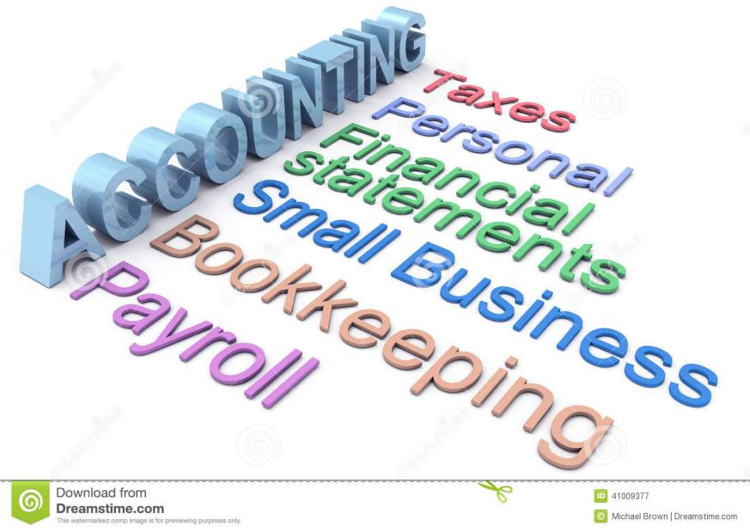

( Figure 2 ) ( Accounting, 2015 )